 CHEMICAL ENGINEERING TRANSACTIONS  VOL. xxx, 2026 | A publication of  
The Italian Association
of Chemical Engineering
Online at www.cetjournal.it

Guest Editors: Petar S. Varbanov, Athanasios I. Papadopoulos, Panos Seferlis
Copyright © 2026, AIDIC Servizi S.r.l.
ISBN xxx; ISSN xxx

Combined Virtual Plant Experience and P&ID Reading as Learning Experience for Chemical Plants Safety and Emergency Procedures
Carlo Pirolaª, Giacomo Tondelliª, Alessio Ferlin^{b}, Nicola Bernareggiª, Elena Fioriª, Ilaria Tornelliª, Flavio Manenti^{c}
ª Università degli Studi di Milano, Dipartimento di Chimica – via Golgi, 19, 20133 Milano Italy
^{b} Università degli Studi della Campania Luigi Vanvitelli, via Lincoln, 5, 81100 Caserta, Italy
^{c} Politecnico di Milano, Dipartimento di Chimica, Materiali e Ingegneria Chimica "Giulio Natta", Piazza Leonardo da Vinci 32, 20133 Milano
*Corr. author: carlo.pirola@unimi.it
This study presents a blended learning approach for education in science, technology and engineering, integrating traditional lectures with immersive 3D virtual laboratories. By linking AVEVA XR software with dynamic simulation tools (AVEVA DYNSIM™), students or workers can explore a digital twin of a chemical plant and practice with complex operational and emergency procedures in a safe environment. A key focus is the interpretation of technical documentation, such as Process and Instrumentation Diagram (P&ID) and the Process Flow Diagram (PFD) of the plant, to bridge the gap between theoretical knowledge and industrial practice. This work explores the application of a virtual didactic laboratory in which an emergency scenario is reconstructed for the teaching of safety protocols and the interaction between the plant and its technical documentation. Results show that this synergistic method enhances student engagement and provides essential field competencies rarely addressed in standard academic curricula. This represents a significant advancement in engineering education, leveraging the intelligent use of modern digital technologies to bridge theory and industrial practice in emergency situations.
  - Introduction
Working in industrial sites or with chemical equipment is accompanied by inherent hazards and risks that must be reduced to ensure a safe environment and avoid potential incidents. Despite automation and remote-control systems have reduced the need to expose workers to many dangers of a chemical process, on-site manual labour, operation and decision making remain necessary (Wang et al. 2020). Working in chemical plants requires high specialization and preparation to act safely in the workspace by learning operational procedures and work protocols. Such topics are rarely addressed in academic curricula, as they are often considered aspects of industrial practice learned “on field”. However, these competencies are increasingly demanded in the foundational training of chemical and industrial engineering graduates (Nakai and Suzuki. 2019).
Oftentimes, students approach chemical operations and process units only from exercises, traditional lectures or from laboratory experiences in glass and small scale, lacking a clear understanding of the equipment structure and configuration, as well as its integration in the plant in a real-life situation (Nazir et al. 2012). Moreover, the training to manage potentially hazardous situations and plant accidents is usually relegated to theoretical lessons, while, for safety reasons, practical exercises are usually neglected (Patle et al. 2014).
An appealing and synergistic possibility, complementary to experimental activities or exercises in traditional rooms, is represented by virtual immersive laboratories using 3D virtual software with augmented reality (Naranjo et al. 2020). In order to create a useful tool for students in the virtual plant, the graphic representation has to react to their actions thanks to underlying simulation of the process itself. This allows them to observe the consequences of operating equipment, from entire units down to single valves, and learn the correct procedures. Such simulation must run in real time dynamically and communicate all the operative conditions to the instruments and indicators and be accessible through the commands available in Virtual Reality (VR). The technology grants students a sense of flow and allows teachers to switch between multiple teaching scenarios. VR improves learning outcomes by giving learners more realistic experiences and more immersive scenarios to practice various processes.
During these learning activities, students have the opportunity to observe a faithful reconstruction of the chemical plant and their unit operations, virtually entering and exploring an industrial facility and clarifying theoretical concepts introduced in conventional teaching. This teaching method has some benefits: firstly, for increasing both student engagement and motivation, as it has been observed that active learning can enhance learning experience and efficacy (Allcoat and von Mühlenen 2018). Another benefit could be the sense of spatial presence thanks to an immersive experience with a 360° view due to VR technology. Research has determined that greater spatial presence increases entertainment value, this point generates the perception of value, and this exerts a direct influence on user attitudes and behaviours (Wang and Lin 2024).
Another key limitation of frontal lectures, that can be overcome using virtual laboratories, is represented by the impossibility to train on the use of technical plant documentation such as the Process and Instrumentation Diagram (P&ID) and the Process Flow Diagram (PFD). Learning how to correctly interpret these documents is essential for a truly effective virtual plant visit, enabling students not only to visually recognize plant components but also to understand how the system operates and why it was engineered with a specific structure and configuration. This fosters deeper comprehension of process functionality and engineering design principles.
Concerning safety, a particular application of the virtual plant is the possibility of reconstructing emergency scenarios in which adequate and precise behavior from the operator is required, safely instructing on the procedure to follow with the documentation available. This application is particularly useful since it allows to provide “real” training to emergency situations which otherwise is relegated to theoretical lessons (Fakhru’l-Razi et al. 2003).
In this paper, an emergency scenario was simulated in a virtual chemical plant, and the documentation and procedures were provided to fifty students attending the third year of Chimica Industriale Bachelor Degree of Università degli Studi di Milano to test the effectiveness of the tool for a trainee operator and verify that the students were accustomed to using the technical material.
  - Methodology
The chemical plant recreated in the virtual reality environment is a Crude Distillation Unit (CDU) in which crude oil is refined into its most common products by classical rectification. The plant is composed of a crude oil pretreatment section and a refinery section. In the first, crude oil is divided into two parallel streams, heated in two heat exchanger trains and treated with water in desalters. The stream coming from the pretreatment section undergoes a first rough separation in a flash drum and then is further processed in the main rectification column from which three intermediate cuts are collected and sent to three stripping columns. Bottom, light and intermediate fractions are cooled and stored in devoted tanks located in the plant. The heat necessary to plant operations is provided by a furnace fed with natural gas. The entire plant was designed and developed to the minimum detail to process 1130 m³ h⁻¹ of crude oil and was described in detail in previous publications (Pirola et al. 2020). The choice of a CDU allows to exploit a well-known process, where all unit operations have been studied and optimized through decades, to provide a very detailed, complex and realistic “working environment”.
The Virtual Plant experience is provided by a series of software interlinked between them. The responsible for the accurate dynamic process modelling, is AVEVA DYNSIM™, a software able to provide equipment models to correctly represent plant functioning during several processes, models to depict process control systems, correct representations of the electrical and mechanical components and thermodynamic models to return precise outputs of the operating conditions. DYNSIM™ is a dynamic simulation software that responds in real time to working parameters changes and so results suitable to simulate the plant behaviour in changing operating conditions.
The 3D interactive environment was developed with the aid of a CAD starting from the P&ID of the crude oil distillation plant. The final geometries are used by the AVEVA XR software to provide a detailed representation of the plant, including the layout and interactive elements such as valves, process instruments (temperature, pressure, level, flow), engine control panels, and related equipment. The 3D model is coupled with the dynamic simulation in DYNSIM™ through the AVEVA SIMULATOR BRIDGE software, which links field actions to the simulator via bidirectional communication. As a result, any manual operation performed by a student in the 3D plant is sent to DYNSIM™, which returns the corresponding process response, ensuring realistic system behaviour (Figure 1).
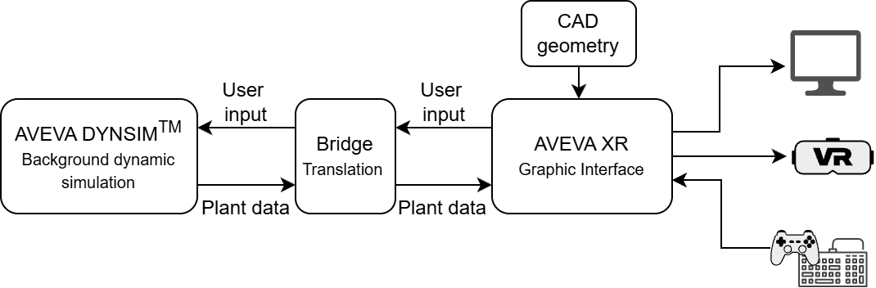
Figure 1: Schematic representation of the virtual reality software.
Immersion is reinforced through dynamic elements such as animated equipment, sounds, and weather-condition simulation. Students can move around the plant, manipulate realistic control instruments (e.g., valves, panels, indicators) using keyboard, mouse and gamepad.
The virtual simulator tool gives the student the possibility to work in different scenarios (normal plant operations, accidents, start-up or shutdown of some sections) that can be faced in real chemical plants. For each scenario, some missions composed by a list of operations that the student must perform to complete the assigned task (e.g. start-up of the furnace) are available. The simulator also gives a score system to evaluate the operator’s preparation to real plant managing, which is based on the successful completion of the mandatory steps, the right decision making based on the plant parameters, the correct answering to occasional quizzes to check the operator’s understanding, the time used and the punishment for wrong actions. Such score system allows for the instructor to have a direct measure on the operator performance and improvement, with a log of the previous trials for tracking the improvement through time. With the objective of using the AVEVA XR software as training tool, missions are available in “tutorial” or “assessment” mode. In the first case the student is guided by the software through the operations required to complete the task, highlighting following steps to follow and suggesting equipment placements. In the latter the task is assigned to the student that is required to complete it, accounting only on his knowledge and the documentation at disposal. The last possibility for the student in to work in “free mode”, moving freely in the plant to familiarize with the various equipment present. In this mode no task is assigned, but the students can still interact with plant components. Before entering the virtual plant, the student must select the personal protection equipment according to the task to complete. The choice of correct PPE is considered in the final score.
This paper focuses on the management of a severe hazard caused by a fire. In the selected scenario, a leak in a pipe downstream pf the pre-flash causes the spread of flammable liquid near the pre-flash itself and its subsequent ignition (Figure 2).
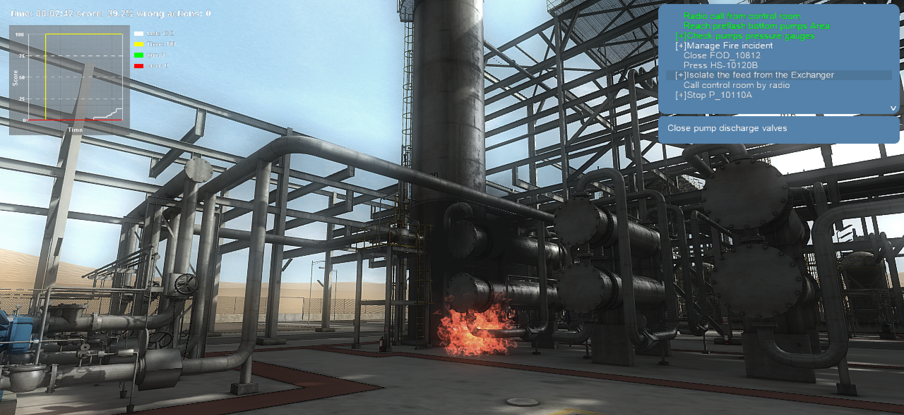
Figure 2: screenshot of the leakage catching fire taken from the scenario reconstruction in “tutorial mode”. On the top left it is visible the progression graph for the mission and on the top right the list of tasks, with in green the ones completed.
For the following mission description, the student or trainee using the AVEVA XR software will be referred as operator. At the beginning of the mission, the operator is asked by the control room to check an anomalous pressure reading in one of the three pumps downstream the preflash. The pressure of one of the pumps is significantly lower than the normal operating value due to a leakage in the delivery pipe. After confirming the pressure lecture, the spilled hydrocarbons catch fire. The operator is required to alert other workers in the plant: contractors are evacuated while other colleagues are asked to shut down the furnace. Then the mission continues with the extinguishing of the fire and the operation to insulate the damaged area to secure the plant.
The detailed tasks are listed in Table1. They must be performed in the given order in a brief time span to avoid the explosion of the flash column and the destruction of the plant.
Table 1: List of tasks to correctly manage the emergency
# | Description of the task | Equipment to interact with
1 | Answer a radio call, the operator is required to check an anomalous pressure reading  at the preflash drum bottom pumps. | -
2 | Read the analog pressure gauges of the pumped streams. A few meters away, a leakage catches fire when the task is concluded. It is possible to see that the spill comes  from a pipe exiting the pumps and entering a heat exchanger (E_10110A). | PG_10170A, PG_10170B, PG_10170C
3 | Call the control room by radio to signal the fire and its location. | -
4 | Locate a colleague, alert him and tell him to perform the furnace shutdown. | -
5 | Locate contractors present in the plant, alert them and tell them to evacuate. | -
6 | Call the control room to update on the situation and ask to turn on a fire hydrant. | -
7 | Extinguish the flames. | -
8 | If safe, close the manual valve right before the leakage. | FOD_10812
9 | Trip the automated valves at the bottom of the preflash (on the pipe feeding pumps  P_10020ABC) and the pumps by setting to “local” and pressing the local trip button. | HS_10120B
10 | Close the manual valves on the pipes exiting the pumps P_10020ABC. | P_10020_A_DIS  P_10020_B_DIS  P_10020_C_DIS
11 | Update the control room that the fire and leakage are contained and get instructed. | -
12 | Stop the pump that sends the atmospheric distillation column residue to the heat  exchanger where the leakage was located as hot fluid. | P_10110A
13 | Switch off the pumps feeding the crude oil to the plant by setting to “manual” and  pressing “stop” on the control panel. Three out of four are active in the mission  scenario. | P_10010A,  P_10010B,  P_10010C
14 | Switch off the pumps previously tripped by pressing the “stop” button on their control  panel. | P_10020A, P_10020B, P_10020C
15 | Call the control room to ensure the correct emergency management. | -
16 | Check the temperature of the internal trays in the atmospheric distillation column to  ensure the correct switch off of the furnace and the closure of the feed streams. | TG_10780
17 | Evacuate the site. | -

In this mission, the operator must accomplish its tasks with special time limitations, from the moment the leakage catches fire, the flames must be put off in three minutes (from task #2 to task #7) otherwise they expand, reaching the preflash drum and causing an explosion. After that, the time taken from the operator only affects the final score. This system forces the student to take fast decisions and be well prepared on the equipment position, as well as be aware of the position of colleagues and other people in the plant in the moment of necessity. Moreover, incorrect actions are penalized, allowing for only four wrong actions before giving a score equal to zero, highlighting the importance of acting strictly according to the protocol in a situation like the one simulated. From Table 1 it is also possible to observe that the equipment is referred with the unique code represented in the P&ID (Figure 3).
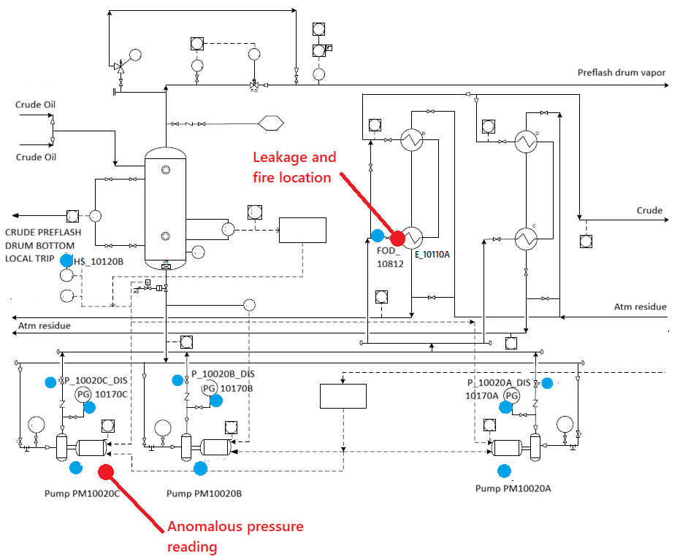
Figure 3: P&ID of the section where most of the tasks are located, every blue dot corresponds to a manual operation conducted during the mission.
The mission was assigned to a sample of fifty students which had followed a prior theoretical explanation of the units present in the virtual plant of two hours. Before the mission, they were given a short familiarization session with the plant units in order to let them recognise the elements and practice the way of interacting with the equipment. Forty percent of the students completed a training by solving two different missions before being assigned the one proposed by this work. For the other sixty percent, this was the first mission.
  - Results
In Table 2 are reported the times and scores of the students trying the mission. What was observed was that students that had tested other missions were more acquainted to the plant instrumentation and had faster responses, sometimes already expecting which could be the following task based on the observations collected in the mission.
Table 2: scores of the students on the fire management scenario.
Students experience | Average time to complete the mission | Average number of wrong actions | Average score
It was their first mission after the virtual plant visit  (30 students) | 15 min and 52 s | 3.2 | 46.92%
They already completed other missions  (20 students) | 7 min and 49 s | 1.6 | 76.75%

It was observed that the prior knowledge on the specific plant section where the emergency takes place is fundamental for an effective response of the operators.
By repeating the mission described in this work, any operator can learn the correct procedure to deal with a fire in a refinery. Beyond the specific case, the exercise is also useful to understand some generic standards, e.g. the different roles of the workers during the emergency and the importance of securing the plant after an accident has occurred.
The operator can also become familiar with the plant documentation relative to the plant (P&ID and PFD). In this way he knows how to manage and use them in a risk situation without losing time. The use of the plant P&ID along with the instruction given by the simulator allows the operator to better understand the reasoning behind each required action.
From a didactical point of view, the use of virtual reality is strongly recommended. As just described, it cannot substitute a theoretical study and the classical frontal lectures, but the synergic application of both these teaching strategies allows to better understand the reasoning of action taken in a real plant by showing the students the consequences of their behaviour.
  - Conclusions
In this article, a virtual immersive chemical plant was used as a learning tool for the preparation of students or trainees on the management of emergency situations on the base of previous knowledge of the plant and the availability of technical documentation and protocols.
The software revealed to be an effective tool for the accustoming of people involved to the plant equipment and to the fast interpretation of PFD, P&ID and procedures. In particular, the synergic use of virtual reality coupled with classical theoretical lessons allows students to acquire experience that is normally relegated to on-field practise. The possibility to appreciate the effect of operator’s actions and to commit errors and observe the consequences without being exposed to any risks, as well as the appreciation for the longer response-time that a large facility shows respect to laboratory standards was proven useful to the in depth understanding of the plant behaviour. These learning opportunities result fundamental when students need to be trained to perform potentially hazardous operations or to manage dangerous accidents as described in this work.
By simulating a high-pressure emergency in a limited time frame, the tool not only tests the student’s technical knowledge, but also his ability to maintain concentration and follow safety protocols under stressful conditions. This is a major advantage of this teaching method, as it allows students to make mistakes and try again without the catastrophic consequences that would occur in a real chemical plant.
References
Allcoat, Devon, and Adrian von Mühlenen. 2018. “Learning in Virtual Reality: Effects on Performance, Emotion and Engagement.” Research in Learning Technology 26(0). doi:10.25304/rlt.v26.2140.
Fakhru’l-Razi, A., S. E. Iyuke, M. B. Hassan, and M. S. Aini. 2003. “Who Learns When Workers Are Trained? A Case of Safety Training of Maintenance Contractors’ Workers For A Major Petrochemical Plant Shutdown.” Process Safety and Environmental Protection 81(1):44–51. doi:10.1205/095758203762851985.
Nakai, Atsuko, and Kazuhiko Suzuki. 2019. “Safety Training System Using Plant Simulator for Distance Cooperative Work in Chemical Plants.” Chemical Engineering Transactions 77.
Naranjo, Jose E., Diego G. Sanchez, Angel Robalino-Lopez, Paola Robalino-Lopez, Andrea Alarcon-Ortiz, and Marcelo V. Garcia. 2020. “A Scoping Review on Virtual Reality-Based Industrial Training.” Applied Sciences 10(22):8224. doi:10.3390/app10228224.
Nazir, Salman, Roberto Totaro, Sara Brambilla, Simone Colombo, and Davide Manca. 2012. “Virtual Reality and Augmented-Virtual Reality as Tools to Train Industrial Operators.” Pp. 1397–1401 in.
Patle, Dipesh S., Zainal Ahmad, and Gade P. Rangaiah. 2014. “Operator Training Simulators in the Chemical Industry: Review, Issues, and Future Directions.” 30(2):199–216. doi:doi:10.1515/revce-2013-0027.
Pirola, Carlo, Cristina Peretti, and Federico Galli. 2020. “Immersive Virtual Crude Distillation Unit Learning Experience: The EYE4EDU Project.” Computers & Chemical Engineering 140:106973. doi:10.1016/j.compchemeng.2020.106973.
Wang, Fang, Jingjing Wang, Jingzheng Ren, Zhiwei Li, Xiaopeng Nie, Raymond R. Tan, and Xiaoping Jia. 2020. “Continuous Improvement Strategies for Environmental Risk Mitigation in Chemical Plants.” Resources, Conservation and Recycling 160:104885. doi:10.1016/j.resconrec.2020.104885.
Wang, Yi-Ting, and Kuan-Yu Lin. 2024. “Virtual Reality-Based Online Learning System Adoption: A Research Framework and Empirical Study.” Online Information Review 48(6):1233–51. doi:10.1108/OIR-05-2022-0307.

